Permanente redirect from HTTP to HTTPS

Step 1: Deploy the Frontend Config file on the cluster level.  
   
*kubectl apply -f frontend.yaml

apiVersion: networking.gke.io/v1beta1

kind: FrontendConfig

metadata:

name: frontend-config

spec:

redirectToHttps:

enabled: true

responseCodeName: PERMANENT_REDIRECT

Use this file to deploy

Step 2: Verify frontend config file is deployed on cluster or not under the object browser on GKE.  
  
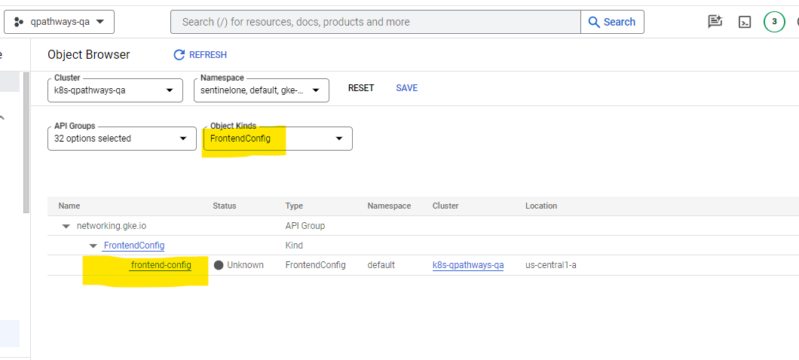  
  
Short by the object kind: FrontendConfig  
  
Step 3  
  
Make the ingress Ip static and provide the name of that static Ip like this below.  
  
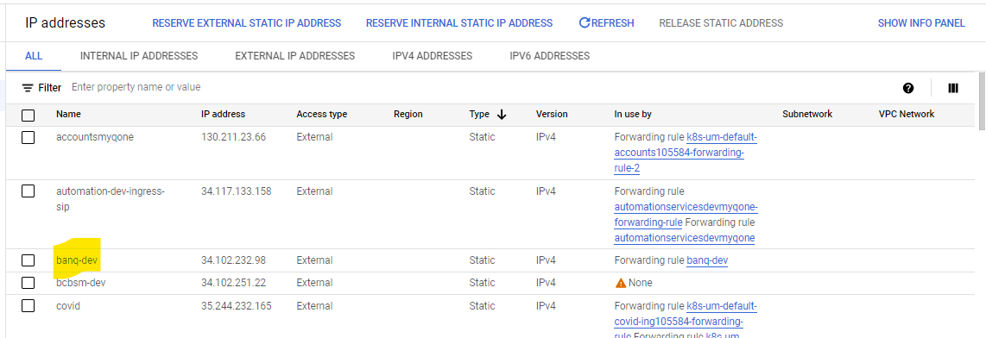  
  
Step 4: Add the annotation on the ingress level.  
Add these below three annotations Highlighted on below image and mention the static Ip name on global-static-ip-name  
  
  
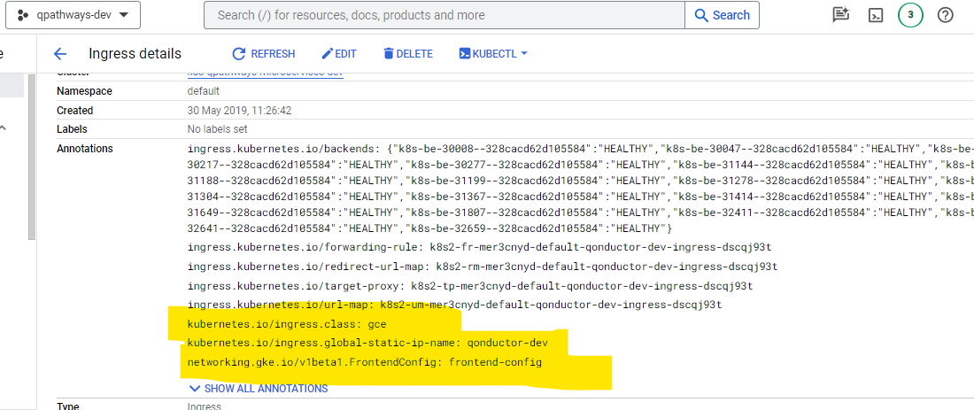  
  
  
After that go and check on the load balancer section https ip is redirect into static Ip.  
